Sermon Notes:

Keep In Your Prayers

Our nation, government, and first responders
(Law enforcement, paramedics, firefighters).

In The Military: Josh & Alissa Paine; Dalen Paine

Pray For: The Salvation of family, friends, and neighbors
who do not know God’s Grace through Faith in Jesus Christ.

Pray For Those who are homebound:
Helen Harrison, Marilyn Miller, Lorraine Newbold

Pray For those recovering from surgery or in healing process:
Marlan Lyon, Seuzi Conlee, Evonne Wright, Frank Millar,
Ron LeFore, Reyna Araniva

Please contact Pastor Teru
if there is an emergency:
Pastor Teru Kondo
Welcome to The Lord’s Day
Worship Service at Bethel Church.

We are truly blessed to be here this morning as we open God’s Word together, sing His praises, and enjoy a time of fellowship in His presence.
(253) 229-0889

209 SW First Avenue,
Milton-Freewater, OR 97862
541-938-3111
Bethelbaptistmf@gmail.com
www.bethelbaptistmf.com
https://www.facebook.com/bethelbaptistmf/

Office Hours: Monday through Thursday,
8:00AM ~ 12:00PM

Items for the bulletin should arrive to
bethelbaptistmf@gmail.com by Thursday morning.

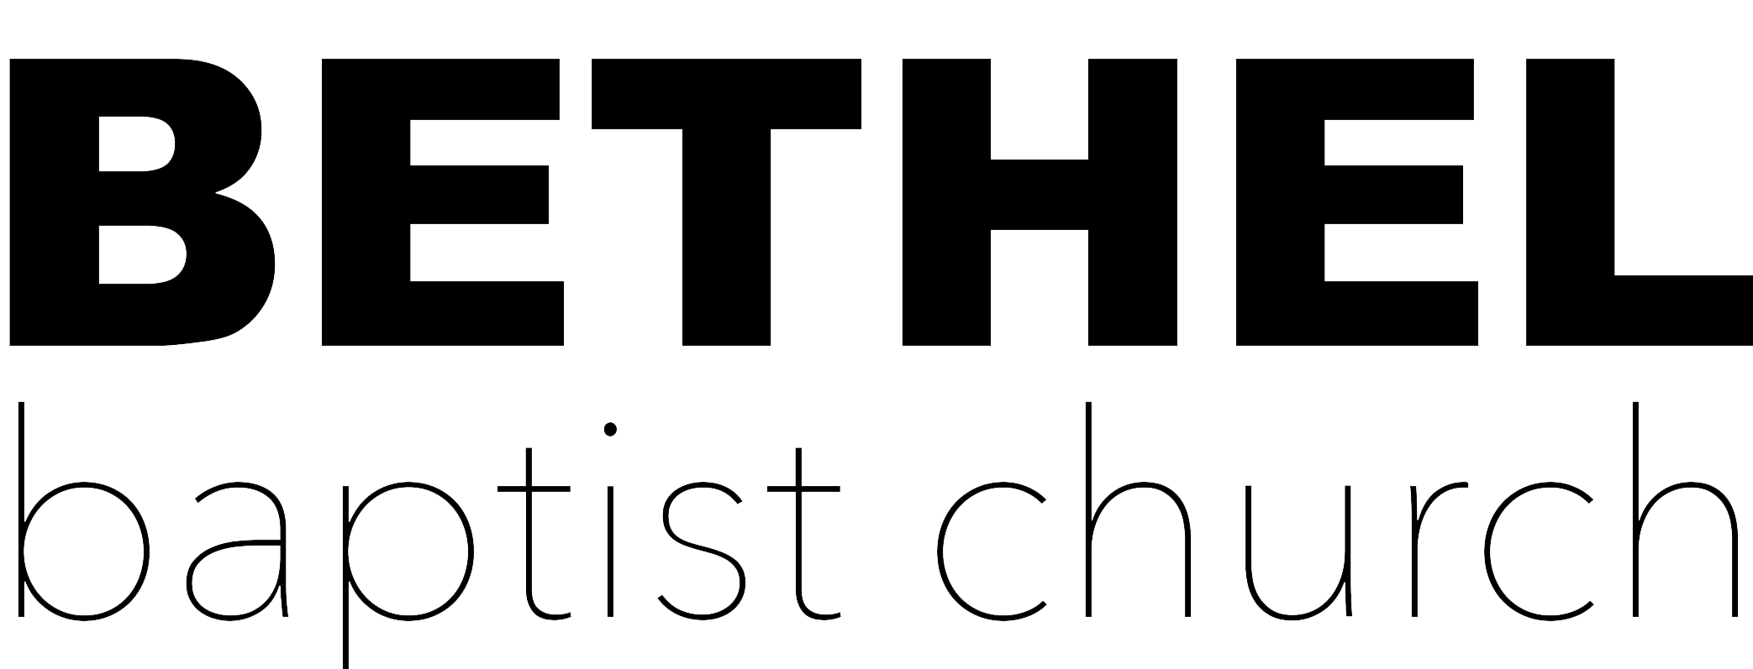

MILTON FREEWATER

December 10, 2023
9:00AM
Easter Sunday Potluck Brunch & Church Family Gathering

10:30AM
Easter Worship Service

Prelude

Call to Worship
Who Is He Yonder Stall (Wondrous Story)
Who Is This
Come Behold The Wondrous Mystery

Scripture Reading & Prayer

Welcome/Announcements/Offertory

Congregational Singing
Your Words Are Wonderful (Psalm 119)

Children Dismissed

Message: “Whom Do You Fear?”- Part 1
Selected Scriptures
- Teru Kondo

Closing Song
All My Boast Is In Jesus

Please remember to pray for
the ministry of the week.

Hope House, Marsing, ID

Ministry of the Week
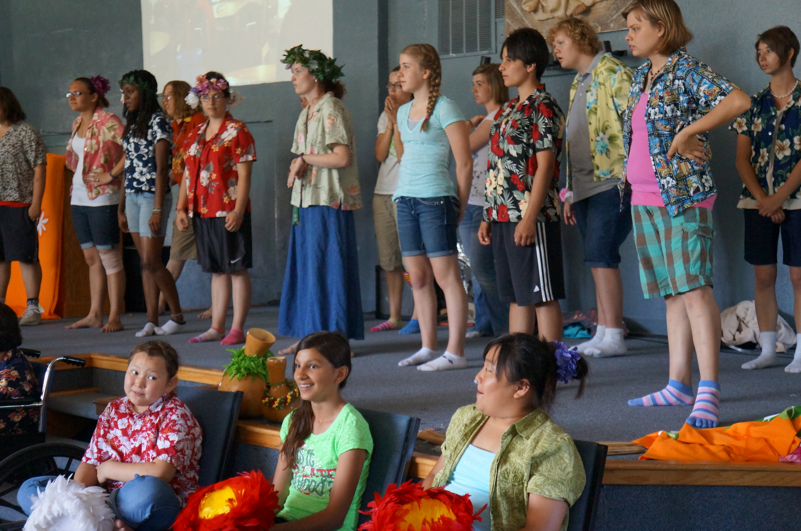

9:00AM - Check-In Station will be available 8:45AM.
Please arrive early, so we can start on time.

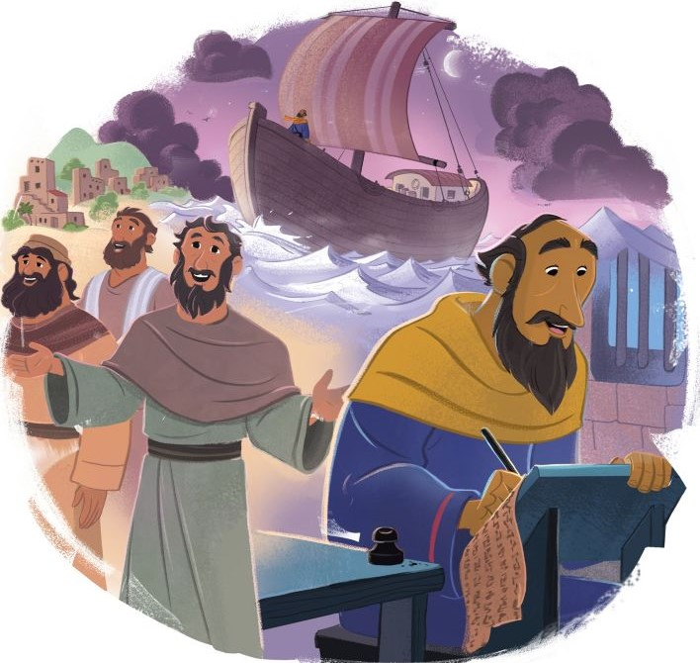
The Bible in One-Year Reading Plan

Hosea 1 – Amos 6 (2-3 Chs. per day)
Revelation 1 – Revelation 7 (1 Ch. per day)

Small Group Schedules

- (Sunday) At Bethel: 7:00 ~ 8:00PM, "The Attributes of God."
Winter Break (No Meeting in December)

- (Sunday) At The Nafziger’s: 6:30PM ~ 8:00PM,
12/10 (No Meeting on 12/17, 12/24 & 12/31)

- (Wednesday) “Journey” At The Conlee’s: 6:30PM ~ 8:30PM,
12/13 (Supper 6:00pm) & 12/20 (No Meeting on 12/27)

- (Every other Sunday) At Jeff & Kate Lyon’s:
5:30PM ~ 7:30PM “The Book of James”
12/3 & 12/17 (Dinner @ The Lyon’s 5:30pm)

Reimbursement Request,
Donations & Tithes Due
All year end reimbursements/purchases are due no later than 12/17.
All tithes/donations will be accepted through 12/31. If you have any questions, please contact Sue Wright. Thank You.

Christmas Craft Day for Kids
Saturday, Dec. 9th, 1:00pm-3:00pm @ Gym

We will have a craft day for kids to make crafts for their families as gifts for Christmas. This is for any age of kids to participate in. Please sign up your kids to know how many to plan for. Signup sheet is in the foyer.
Children’s Ministry Training
Friday, Dec. 8th, 5:30pm-7:00pm

Training for Children’s Ministry workers to go over the highlights of
our Child Protection Policy. We will also provide training on nursery curriculum. We plan to order pizza for the participants.

Gifts and Offerings are not taken during the worship service.
A secure offering box is located at the back of the worship
center next to the sound booth and in the church office.
A monthly financial summary is available in the church office.
Volume 11: The Church United helps kids discover how the missionary Paul took the gospel throughout the Roman Empire and the church grew. In the Great Commission, Jesus commanded His followers to make disciples of all nations. Early church leaders made disciples by sharing the gospel, baptizing new believers, and teaching them to obey Jesus. Our mission as Christians is to make disciples of all nations by the power of the Holy Spirit. By reading and studying the Bible, we can remember what is true and encourage others as they live by faith.
THIS WEEK – December 10, 2023

Sunday: 8:15 AM Music Practice
8:30 AM Prayer Meeting
9:00 AM Sunday School – All Ages
10:30 AM Morning Worship
11:00 AM Children’s Church
7:00 PM Bible Study @ Bethel
Wednesday: No Music Practice
Thursday: 9:30 AM Ladies Prayer & Praise (Contact Mildred Lyon)

For recordings of past sermons or for more information
about our church, please visit www.bethelbaptistmf.com

Adult Sunday School
“OLD TESTAMENT SURVEY I”
With Abner Chou, Genesis ~ Numbers
Sunday, 9:00AM, @ Gym

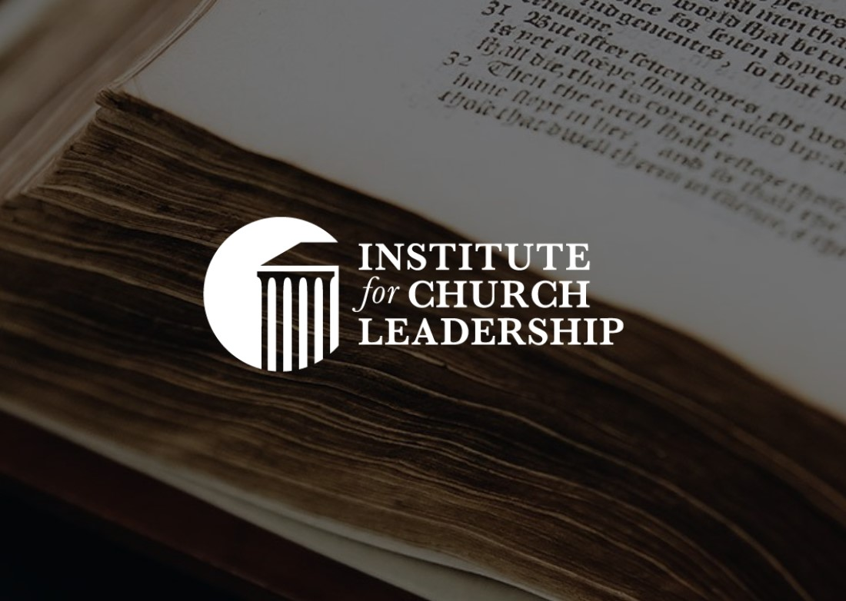
The Institute for Church Leadership is a series of online courses providing advanced doctrinal, biblical, and ministry training for church leaders and committed students of God's Word. These courses are taught by various Master's Seminary's professors and pastors.

Sunday School (Primary & Juniors)

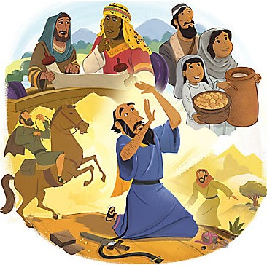

FOUNDATIONS (Genesis) is designed for those who may not have grown up in the church or for those who desire to see the overall movement of God as He reveals Himself and His loving plan to bring us back into a proper relationship with Himself. This is a twelve weeks class that will take a high altitude look at the major events and people God used to save us from sin and death. This class will be taught by Mike Boettcher. It will combine lecture with discussion.

